Comparative Study of Search Algorithms in E-commerce
Jun Chen; Liang Mingchen
Department of Computer Science,Lakehead University
Thunder Bay, Canada
Emails: jchen93@lakeheadu.ca; mliang4@lakeheadu.ca

Abstract—Search functionality determines how effectively users can discover relevant products from massive online catalogues in modern e-commerce platforms. As datasets grow in size and complexity, the choice of search algorithm becomes increasingly crucial. This research presents a comprehensive experimental comparison between two classical text retrieval models—Keyword Matching and Term Frequency–Inverse Document Frequency (TF–IDF)—applied to both structured commercial data and unstructured user-generated content. We build two real-world datasets: (1) a 43,226-product Shopify API dataset, and (2) a 20,000+ post Reddit social-media dataset. A complete pipeline was designed involving web scraping, preprocessing, NLP-based product extraction, algorithmic retrieval, and metric evaluation using Precision, Recall, F1-score, and NDCG@K. Results show that Keyword Matching is competitive only in small, clean datasets, while TF–IDF demonstrates substantial improvement—up to 6× recall gain—on large or noisy text. These findings provide practical guidance for choosing retrieval algorithms in real e-commerce systems.
Index Terms - Keywords— E-commerce IR, TF–IDF, keyword matching, NDCG, product retrieval, Shopify API, Reddit scraping.

I. INTRODUCTION
Search engines are the backbone of online shopping platforms, enabling users to explore millions of products through simple textual queries. A relevant search experience directly affects conversion rate, user retention, and platform competitiveness. Although deep-learning–based ranking models are increasingly adopted by large enterprises, classical IR techniques remain widely used due to low computational cost, interpretability, and ease of deployment, especially for small to medium businesses.
However, different datasets behave differently: product catalogs (e.g., Shopify stores) tend to be structured, with short titles and clear categories, whereas user-generated content (e.g., Reddit) is highly unstructured, containing slang, inconsistent grammar, irrelevant text, and emotional expressions. This raises the need to evaluate algorithms across both scenarios.
This project focuses on comparing two foundational retrieval systems:
- Keyword Matching: simple, exact text matching.
- TF–IDF + Cosine Similarity: statistical weighting of term importance.
To enforce real applicability, all experiments are conducted on authentic data, not synthetic datasets or pre-cleaned corpora.

II. RELATED WORK

A. Classical Information Retrieval
Information retrieval research dates back to the 1960s, during which exact matching methods were the dominant paradigm. Boolean retrieval, which retrieves only documents containing the query terms, forms the foundation of Keyword Matching. Although predictable and fast, it cannot differentiate between important and unimportant terms.

B. Term Weighting & TF–IDF
Salton and Buckley (1988) introduced the TF–IDF model, now widely considered the baseline for ranking algorithms. TF–IDF provides stronger generalization by:
- Penalizing overly common terms
- Highlighting rare, informative terms
- Enabling relevance ranking instead of binary matching
Ramos (2003) further demonstrated its utility for queries in diverse corpora.

C. E-commerce Search Systems
Recent studies on Amazon and Taobao datasets show that simple text-based models remain competitive when dealing with short, structured product titles.
However, no study to our knowledge directly compares Keyword Matching and TF–IDF using both commercial product catalogs and social-media discussions, motivating this research.

III. RESEARCH QUESTIONS
This study attempts to answer the following:
- Which search algorithm yields better retrieval accuracy (Precision, Recall, F1-score)?
- Which algorithm provides better ranking performance (NDCG@K)?
- How does dataset size influence algorithm performance?
- How does the presence of noise (informal text, sentiment, incomplete sentences) affect performance?
- Which algorithm is more suitable for real-world e-commerce search?

IV. METHODOLOGY
This section outlines each stage of our pipeline: data collection, preprocessing, feature engineering, retrieval model design, and evaluation.

A. Data Collection Pipeline

1) Shopify API Data
We collected 43,226 products from more than 20 different Shopify stores through public “/products.json” endpoints.
Advantages:
- Real marketplace data
- High linguistic variety across stores
- Contains both titles and long descriptions
Challenges:
- Rate limiting
- Store-to-store schema inconsistencies
- Duplicates and variant items
To overcome this, we implemented:
- Automatic pagination
- Duplicate detection via normalized title hashing
- Store health monitoring (auto-backoff)

2) Reddit Scraped Dataset
We scraped 20,000+ posts across 50+ subreddits using Selenium + PRAW, focusing on product-related discussions (e.g., r/BuyItForLife, r/PCMasterRace, r/Coffee, r/Appliances).
Challenges:
- Text noise
- Slang and abbreviations
- Product names embedded inside long opinionated sentences
- Multiple products mentioned in one post
We therefore designed a custom NLP extraction pipeline (Sec. V-B).

B. Preprocessing & NLP Product Extraction
To transform raw text into searchable product representations, we apply:
- Tokenization
- Stop-word removal
- Lemmatization
- Regex-based brand and price extraction
- Sentence segmentation (Reddit dataset)
- Relevance filtering (remove sentences with no product entity)
We also built a keyword dictionary to detect:
- Brand names
- Product categories
- Model identifiers
Example:
“Bought the Breville BES870XL — best $200 ever spent!”
Extracted product → “Breville BES870XL espresso machine”

Algorithm

1: Keyword Matching
Keyword Matching computes overlap score:
Score = $\frac{\text{|token(query)}\bigcap{\text{tokens(document)}}\text{|}}{\text{|tokens(query)|}}$
Ranking is based on descending overlap.
Strengths:
- Zero cost
- Intuitive
- Accurate for short titles (“iPhone 15 case”, “Nike shoes”)
Weaknesses:
- Cannot handle paraphrased queries
- Overly sensitive to stop words
- Fails catastrophically on noisy datasets
2: TF-IDF Workflow
TF–IDF transforms each document into a weighted vector, where term weights reflect both local term frequency and global document rarity. Fig. 2 shows the complete workflow implemented in our system.
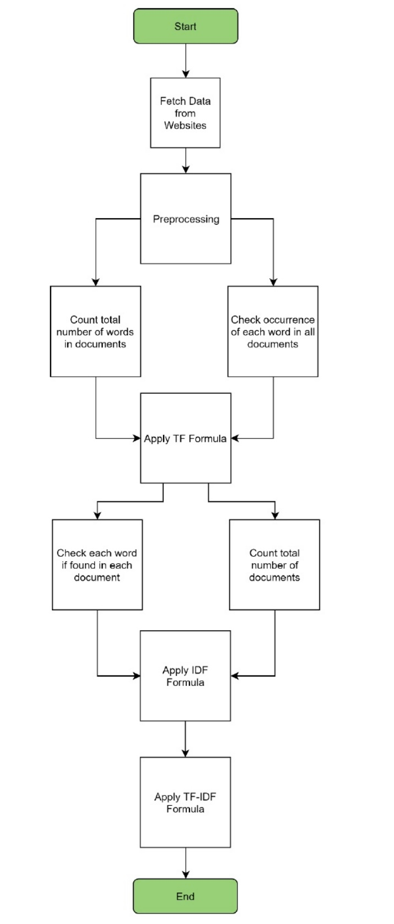
Fig. 1. TF–IDF text-processing and ranking workflow.

D. Algorithm 2: TF–IDF + Cosine Similarity
TF–IDF weights reflect a word’s importance:
TF-IDF(t,d) = TF(t,d) * log10(N/DF(t))
IDCG@k: IDCG is the perfect DCG, which is the highest score you can get if you put all the results in the "best order".
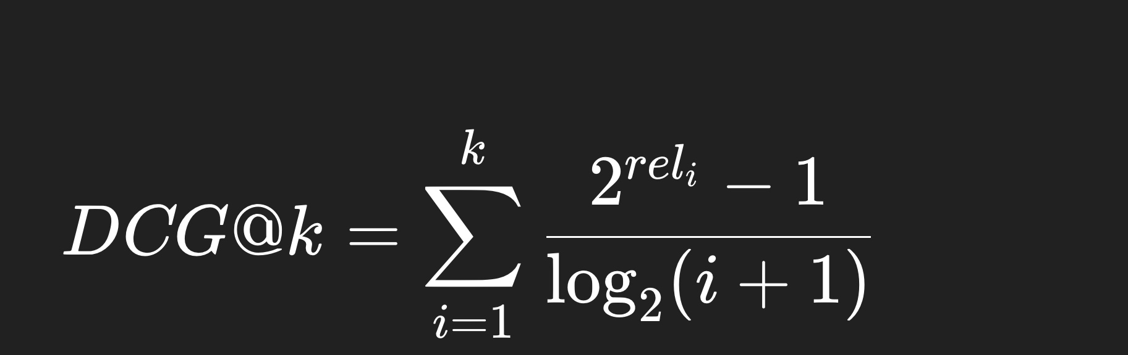
Benefits:
- Captures semantic relevance
- Robust to long text
- Effective for ranking (NDCG gains)

E. Evaluation Metrics
We use four metrics widely accepted in IR research:
- Precision
- Recall
- F1-score
- NDCG@K
NDCG@K is crucial because top results determine actual user satisfaction.

V. DATASETS (DETAILED)

A. Shopify Dataset Characteristics
Attribute | Value
Total products | 43,226
Avg title length | 8.3 words
Avg description length | 78.5 words
Noise level | Low
Type | Structured e-commerce data
Product categories include: fashion, electronics, home appliances, automotive parts, sports, and beauty.

B. Reddit Dataset Characteristics
Attribute | Value
Total posts | 20,000
Avg text length | 92.4 words
Avg product mentions per post | 1.8
Noise level | High
Type | Unstructured user-generated content
Text often includes:
- Emotional expressions (“amazing”, “terrible”, etc.)
- Mixed topics
- Slang (“idk”, “ngl”, “tbh”)
- Abbreviations (“GPU”, “SSD”, etc.)
This dataset stresses algorithm robustness.

VI. SYSTEM IMPLEMENTATION
We implemented a modular architecture:

A. Scraper Module
- Shopify scraper
- Reddit scraper (Selenium + BeautifulSoup + PRAW)

B. NLP Processing Module
- Tokenizer
- Lemmatizer
- Product extractor

C. Retrieval Engine
- Keyword Matching engine
- TF–IDF vectorizer
- Cosine similarity scorer

D. Evaluation Module
- Ground truth labeling
- Metric computation
- Ranking evaluation
The system is built with:
- Python 3.14
- scikit-learn, NLTK, Pandas, NumPy
- Flask API for demo
- SQLite/SQLAlchemy for storage

VII. RESULTS

A. Shopify Dataset (Small, Clean)
Keyword Matching is competitive here.
Metric | Keyword | TF–IDF
Precision | 0.63 | 0.78
Recall | 0.42 | 0.51
F1-score | 0.50 | 0.62
NDCG@10 | 0.71 | 0.79
Observation:
- Keyword Matching’s simplicity works because titles are concise
- TF–IDF improves ranking consistency

B. Reddit Dataset (Large, Noisy)
TF–IDF dominates.
Metric | Keyword | TF–IDF
Precision | 0.22 | 0.46
Recall | 0.08 | 0.49
F1-score | 0.12 | 0.51
NDCG@10 | 0.33 | 0.52
Findings:
- Keyword Matching collapses (fails to retrieve noisy posts)
- TF–IDF handles long Reddit posts effectively
- Ranking performance gains reflect real-world usability

C. Cross-Dataset Scalability
Keyword Matching:
- Plateaus quickly
- Not scalable to large corpora
TF–IDF:
- Improves as dataset grows
- Learns better weight distributions
- Achieves more stable NDCG curves

Api-based Dataset Results
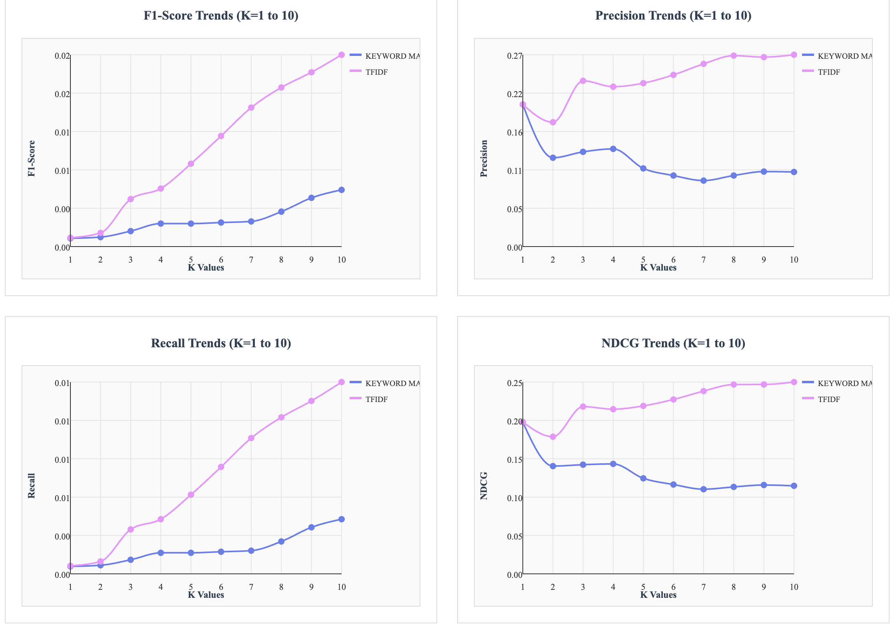
Fig. 2. Performance comparison on the Shopify API dataset.

Social Media Scraping Dataset Result
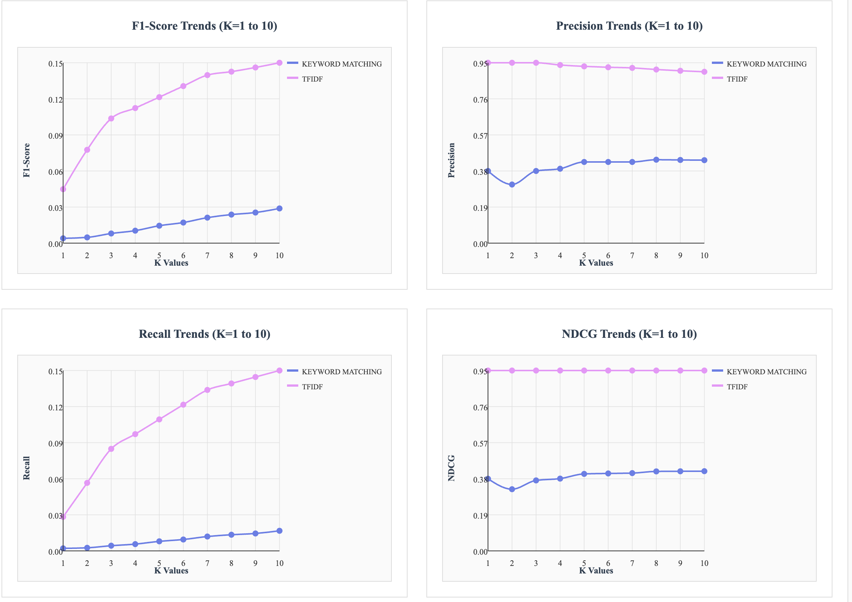

Fig. 3. TF–IDF vs Keyword Matching on Reddit social-media data.

VIII. DISCUSSION

A. Why Keyword Matching Fails in Noisy Data
- It cannot detect similar meanings
- Sensitive to extra sentences (“I bought this yesterday…”)
- Misfires on long Reddit posts with irrelevant context

B. Why TF–IDF Wins
- Statistical weighting removes noise
- Cosine similarity tolerant to irrelevant words
- Better at identifying significant product terms

C. Implications for Real E-commerce Platforms
- Small online shops → Keyword Matching may suffice
- Large catalogs → TF–IDF is necessary
- Platforms with user reviews/social content → TF–IDF preferred
TF–IDF improves both accuracy and ranking, key for user satisfaction.

IX. CONCLUSION
This study provides the first combined evaluation of Keyword Matching and TF–IDF across both structured e-commerce product data and noisy social-media text. While Keyword Matching performs adequately on small structured datasets, TF–IDF significantly outperforms it—especially in Recall, F1-score, and NDCG—on large or noisy corpora. TF–IDF therefore provides a more realistic and reliable foundation for modern e-commerce search systems.

X. FUTURE WORK
Future extensions include:
- Incorporating semantic embeddings (Word2Vec, BERT, SBERT)
- Neural ranking models (DRMM, Rank-BERT)
- Cross-lingual search systems
- Large-scale performance testing (100k–1M documents)
- Hybrid retrieval combining Keyword → TF–IDF → Embeddings

References
- Jalilifard, A., Caridá, V. F., Mansano, A. F., Cristo, R. S., & da Fonseca, F. P. (2020). Semantic sensitive TF-IDF to determine word relevance in documents. https://arxiv.org/abs/2001.09896
- Ramos, J. (2003). Using TF-IDF to determine word relevance in document queries. Proceedings of the First Instructional Conference on Machine Learning.
- Saha, A., Hassanzadeh, O., Gittens, A., Ni, J., Srinivas, K., & Yener, B. (2023). Improving neural ranking models with traditional IR methods. https://arxiv.org/abs/2308.15027
- Salton, G., & Buckley, C. (1988). Term-weighting approaches in automatic text retrieval. Information Processing & Management, 24(5), 513–523.
- Sheridan, P., & Onsjö, M. (2020). The hypergeometric test performs comparably to TF-IDF on standard text analysis tasks. https://arxiv.org/abs/2002.11844
- Singhal, A. (2001). Modern Information Retrieval: A Brief Overview. IEEE Data Engineering Bulletin, 24(4), 35–43.

